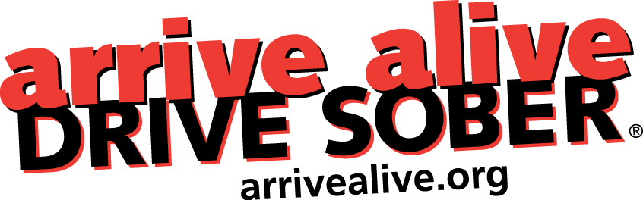

Arrive Alive Conference

Sunday, October 27th, and Monday, October 28th, 2024

Stonehaven Banquet Hall, 63 Eric T Smith Way, Aurora, ON

Join us for our annual Arrive Alive conference designed to update members of the road safety community with regards to the many changes to provincial and federal legislation for arresting, convicting and sentencing impaired drivers in Ontario. We will also review how the sale of cannabis is progressing, and the latest changes for retailing alcohol in Ontario now and in the future.

Speakers and delegates from local police services, health units, municipal government, volunteer groups, and provincial agencies will have the opportunity to get up to speed and exchange information on current trends, concerns, strategies, and discussions around impaired driving in Ontario.

The conference will begin on Sunday with lunch, then our AGM in the afternoon (non-members are welcome), followed by a reception / light dinner in the evening; Monday will be a day of presentations with breakfast and lunch provided.

Registration is $75.00 and includes Sunday lunch and reception, Monday breakfast, lunch, parking, and all sessions. Email our office with the completed form below to arrange payment by cheque, e-transfer, credit card, or other at arrivealive@bellnet.ca

Registration Information

Name: ___________________________________________Title: _____________________________________

Organization: _____________________________________ Address: ___________________________________

City: ______________________________________Province: ____________Postal Code:__________________

Telephone: ( ) ____________________ E-mail: ______________________________________________

I will attend: Sunday AGM: ______ Sunday Dinner & Reception: ______ Monday: _______

Please mail or email this registration form to:
arrive alive DRIVE SOBER 1220 Bayview Avenue, Suite 507, Toronto, ON, M4G 2Z7
Email: arrivealive@bellnet.ca

