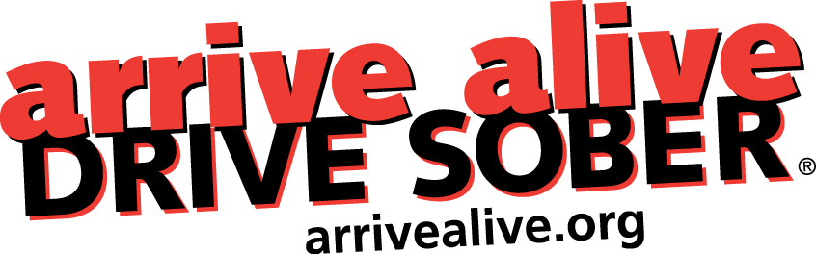

Arrive Alive Conference

Sunday, September 28th, and Monday, September 29th, 2025

Holiday Inn, 1696 Regent Street, Sudbury, ON

Join us for our annual Arrive Alive conference for members of the road safety community. This year’s conference will take a look at urban versus rural concerns, opportunities for solutions, messaging, legislation, and prevention strategies.

Speakers and delegates from local police services, health units, provincial agencies, municipal government, and volunteer groups will have the opportunity to exchange information on current trends, concerns, and discussions, around impaired driving, boating, snowmobiling, and off-roading in Ontario.

The conference will begin on Sunday with lunch, then our AGM in the afternoon (non-members are welcome), followed by a reception / buffet dinner in the evening. Monday will be a day of presentations with breakfast and lunch provided.

Registration: the fee is waived this year. Email our office at arrivealive@bellnet.ca with the completed details below to confirm your attendance.

Registration Information

Name: ________________________________________________________________________

Title: _________________________________________________________________________

Organization: __________________________________________________________________

Address: ______________________________________________________________________

Email: ________________________________________________________________________

I will attend: Sunday AGM/Lunch _________Sunday Evening __________ Monday _________

arrive alive DRIVE SOBER, 1220 Bayview Ave., Unit 507, Toronto, ON, M4G 2Z7
V: 416-485-4411 E: arrivealive@bellnet.ca W: arrivealive.org; Registered Charity # 88075 5939 RR0001

